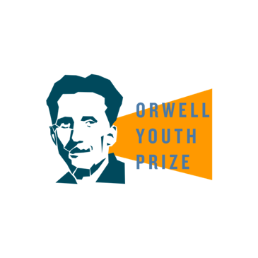
These tasks will help you prepare a piece of writing to enter the

Orwell Youth Prize 2025, on the theme of ‘Freedom is…’

LESSON 1: What is freedom?
Freedom means different things to different people. Have a look at the quotes below. Which statements do you agree with, and why?
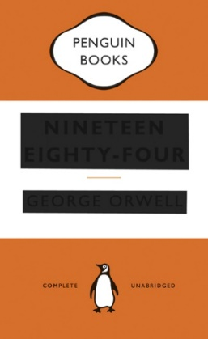
“Freedom is the freedom to say that two plus two make four. If that is granted, all else follows.”
From Nineteen Eighty-Four by George Orwell, published 1949
“I am not free while any woman is unfree, even when her shackles are very different from my own. And I am not free as long as one person of Color remains chained. Nor is anyone of you.”
Audre Lorde, American writer, poet and civil rights activist, in her keynote presentation at the National Women’s Studies Association Conference, 1981
“There is more than one kind of freedom, said Aunt Lydia. Freedom to and freedom from. In the days of anarchy, it was freedom to. Now you are being given freedom from. Don’t underrate it.”
From The Handmaid’s Tale by Margaret Atwood, published 1985
“We, the people, recognize that we have responsibilities as well as rights…that a freedom which only asks ‘what’s in it for me?’ a freedom without a commitment to others, a freedom without love or charity or duty or patriotism, is unworthy of our founding ideals, and those who died in their defense.”
Barack Obama in ‘Remarks by the President at the Democratic National Convention’, 2012
“Lock up your libraries if you like; but there is no gate, no lock, no bolt that you can set upon the freedom of my mind.”
From A Room of One’s Own by Virginia Woolf, published 1929
“We know through painful experience that freedom is never voluntarily given by the oppressor; it must be demanded by the oppressed.”
From ‘Letter from a Birmingham Jail’ by Martin Luther King Jr, April 1963
“Freedom, in fact, is the very source of creativity for both individuals and society. It is not enough, as communist systems have assumed, merely to provide people with food, shelter and clothing. If we have all these things but lack the precious air of liberty to sustain our deeper nature, we are only half human…”
From ‘The Global Community’ by the Dalai Lama (The 14th Dalai Lama, Tenzin Gyatso, is the spiritual leader of Tibet. Since 1959, he has lived in exile in Dharamsala in northern India.)
“If liberty means anything at all, it means the right to tell people what they do not want to hear.”
From George Orwell’s Preface to Animal Farm, published 1945

The Universal Declaration of Human Rights
The Universal Declaration of Human Rights sets out a standard of human rights for all peoples and all nations. Many of these rights are about freedom. You can read them here.
- What freedoms are most important to you? If you had to choose a most important, what would it be and why?
- Are there any other freedoms you would add to this list?
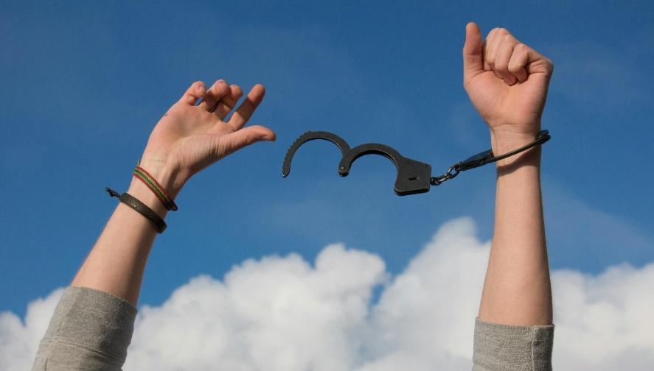
Freedom is…a list poem!
What is a list poem? As the name suggests, a list poem is a poem containing a list of images or adjectives that build up to describe the poem’s subject matter.
Here are some examples:
‘Why We Oppose Pockets for Women’ by Alice Duer Miller
‘Mr Grumpledump’s Song’ by Shel Silverstein
‘I Hear America Singing’, by Walt Whitman
Write a list poem called ‘Freedom is…’
- If Freedom was an animal, what would it be? What about a colour? A taste? A smell? A sound? A texture? A place? An activity? A weather? A… keep adding to this list!
- Think about the freedoms which you have, from small, everyday freedoms like choosing what you want to have for breakfast or what to watch on TV, to big freedoms like the freedom to express your opinions and beliefs.
- You might want to try using similes (saying something is ‘like’ or ‘as’ something else, e.g. free as a bird) or metaphors (saying something is something else, e.g. I am a bird)
- FOR AN EXTRA CHALLENGE – Think about the freedoms (or lack of freedom) which other people in the world experience too. How do their experiences compare and contrast with your own? For example, in Afghanistan, the Taliban have banned girls from going to secondary school. Girls aren’t free to have an education. While you might not always enjoy school, what difference would it make if you didn’t have the freedom to go to school? Check out our ‘Research’ lesson plan to find out more about different freedoms and lack of freedoms, from the Right to Roam to wrongful imprisonment. Does this spark any ideas for your poem?

